PERSONAL INFORMATION | Thushar Tom
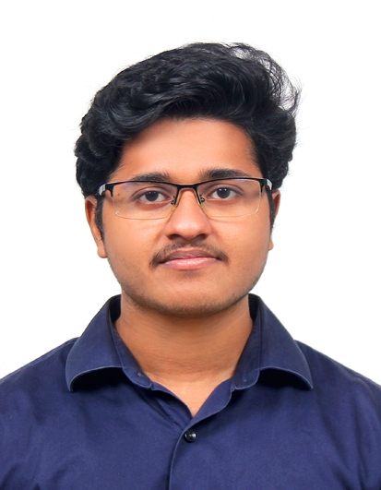 |   Athirampuzha, Kottayam, Kerala, 686562, India
 |  +91 8547934944

thushartom@gmail.com
 | Sex Male | Date of birth 21/03/1998 | Nationality Indian
 | Enthusiastic about robotics, machine learning, and aerial vehicles

WORK EXPERIENCE

1 August 2020 – Present | Software Engineer
1 August 2020 – Present | Founding Minds Software, Infopark, Kochi, Kerala, India  Python developer working on ML object detection for vision-based electronics
1 August 2020 – Present | - US Patent filed for software for golf ball tracking and scoring system  - Designed, prototyped, and developed the body and logic of a vision-based machine to sort golf based on colour using a Jetson Nano  - Trained, and integrated deep learning models  - Built automated data pipelines for computer vision applications  - Created AWS cloud-based ML automation pipelines, Airflow, and MLFlow with Nginx  - Developed software products using Flutter, PyQt5, Flask
1 August 2020 – Present | Business or sector Software Company
Jan 2020 – June 2020 | Hardware Engineering Intern
Kepler Robotics, Kottayam, Kerala, India

Prototyped and developed hardware solutions for small-scale custom applications
- Experienced in protocols such as UART, SPI, I2C, USB
- Developed electronic hardware solutions on developer boards such as ESP32, NodeMCU, Raspberry Pi 4, Pico Pi, Arduino (Nano, Uno, Mega), and Jetson Nano
- 3D printed and modelled different products and casings
- IoT using MQTT and robotics projects implemented using sensors and actuators
 | Business or sector Start-up

EDUCATION AND TRAINING

March 2016- December 2020 |  | B. Tech. in Electronics and Communication Engineering, GPA - 7.44 |  |  |  |  | 2.5 German marking
 |  | University - College of Engineering Chengannur, Kerala, India
- B.Tech. Major thesis – developed ML model using Keras for handwritten character recognition
- Elected technical coordinator for college senate (2019 - 2020)
- IEEE Robotics and Automation Society (RAS) Secretary (2019 - 2020)
- Student representative of the batch (2019 - 2020)
- Co-founded Robocom, a robotics community (2019)
- Entrepreneurship development club chairman (2018 - 2020)
- IEEE Special Interest Group for Humanitarian Technologies Coordinator (2018 - 2019)
- Fabrication lab coordinator (2017 - 2020)
- Received start-up funding for project Sight, an audio aid for the visually impaired (2017)
March 2015- March 2016 |  | Higher Secondary (12th Grade)  Physics, Mathematics, and Computer Science percentage – 84%
 |  | Institute – Bhavans Vidya Mandir, Pottore, Thrissur, Kerala, India
Mother tongue | Malayalam
Other languages | UNDERSTANDING |  |  | SPEAKING |  | WRITING
Other languages | Listening |  | Reading | Spoken interaction | Spoken production
German | A1 |  | A1 | A1 | A1 | A1
 | Goethe A1 Certificate
English | C2 |  | B2 | C2 | C2 | B1
 | IELTS band 7
Communication skills | - Experienced in hosting technical workshops  - Attended national level conferences  - Presented at seminars and workshops
Organisational / managerial skills | - Leadership – Chief coordinator of a national level IEEE hackathon ROBOTHON 5.0 (2019)  - Initiatives -  - Developed a working model of a windmill as a part of the college green initiative  - Hosted events, exhibitions  - Set up menstrual pad vending machine  - Built and distributed power banks during Kerala flood relief (2019)  - Mentoring - IEEE student quality improvement program (ISQIP 2019)  - 3-day hands-on workshop on embedded systems development for 50+ students  - Management - Managed 30+ students for Tronix (2018) and acquired 15+ sponsors  - Volunteering - facilitated IEEE PES, RAS, WIE, and SIGHT events
Coursework | - Demonstrated outstanding performance in engineering laboratories  - Online Certifications -  - Design for IoT, Deep Learning, and Deep Learning for Computer Vision (NPTEL)  - Mathematical Thinking for Computer Science, Version Control using Git (Coursera)  - Undergraduate thesis on ML-based recognition of handwritten receipts  - Implemented binary phase shift keying (BPSK) in signal processing
Technical skills | - Programming: Python, C++, C, Dart, Bash  - Web Technologies: HTML, CSS, Django, Flask, MySQL, DynamoDB, JSON, Apache, Nginx, AWS  - Machine Learning: training, testing, data pipelines, frameworks -TensorFlow, YOLO  - Misc. Technologies: PyQt5, Git, Flutter  - Hardware: Developer boards (Pi, Jetson, Arduino), 3D modelling, 3D printing, laser cutting, vinyl plotter, PCB designing, etching, soldering,  - sensors - flow meter, temperature, motion, gyro, light, moisture, IP camera, Pi cam  - actuators - solenoid valves, motors, servos, steppers, relays  - Tools: Pycharm, VScode, Arduino IDE, Android studio, Adobe suite, Fusion 360, Eagle, PuTTY, Inkscape, Qt designer, GitHub
Other skills | - Photography and video editing
Patent | - Ball tracking system identifying objects by colour (06/08/2021) Patent no - 63208029
Projects | - Sight - A wearable device providing audio aid to the visually impaired. Powered by ML (Yolov3 object detection) on Raspberry Pi. Funded by Kerala State Start-up mission  - Built aerial vehicles – Quadcopter using DJI Naza m-lite & RC aircraft  - Router backup (battery charge-discharge cycles analysed using Arduino and Python)
Conferences | - National summit on SDGs & best practices for technical events, T Summit, SRM Chennai (2019)
Memberships | - IEEE (2016-2020)
Honours and awards | - 1St Prize in Shristi (national level) for Best Robotics Project Award (2019)  - 3rd Prize in ROBOTHON 4.0 (national level) by IEEE RAS SB CEC (2018)  - 1St Prize in Resilience by IEEE WIE (2018)
References | - Dr. Jacob Thomas V, Former Principal, College of Engineering Chengannur, principal@mec.ac.in  - Mr. Anish Chandran, Director of Product Innovation, Founding Minds Software, anish.chandran@foundingminds.com

